Lab Assignment 17
K. VIGNANAND RAO
2303A52439
BATCH 41

Task 1: I-Employee Dataset Cleaning
Prompt used:
Create a Python script in Google Colab to clean an employee dataset. Create a dataset manually using pandas.Handle missing values in salary using median.Handle missing values in designation using mode. Handle missing values in experience using mean.Remove duplicate employee IDs.Convert all job titles (designation) to lowercase. Encode categorical columns (designation, employment_type) using LabelEncoder.Display the cleaned dataset.
Code:
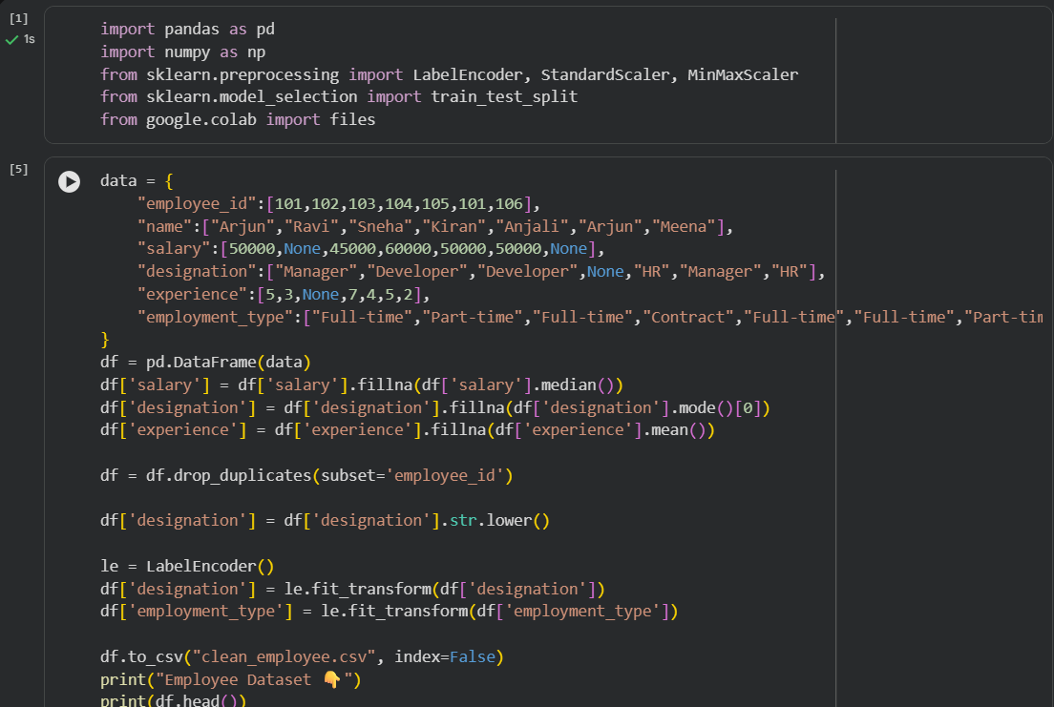

Input:
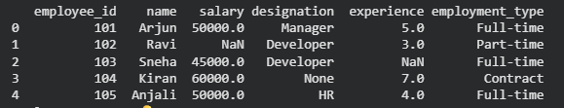
Output:
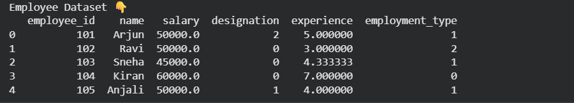
Justification:
In the above task, we performed data cleaning on the employee dataset to ensure accurate HR analysis. We handled missing values in key fields such as salary, designation, and experience to avoid misleading insights. Additionally, we removed duplicate employee IDs and standardized as well as encoded the data, making the dataset consistent and ready for machine learning applications.

Task 2: Student Performance Data Preprocessing
Prompt used:
Create a Python script to preprocess student performance data.Create dataset manually using pandas.Convert exam_date column into datetime format.Extract new features: month, day, and semester.Normalize total_marks using MinMaxScaler.Detect and remove outliers using IQR method.Display the transformed dataset.
Code:
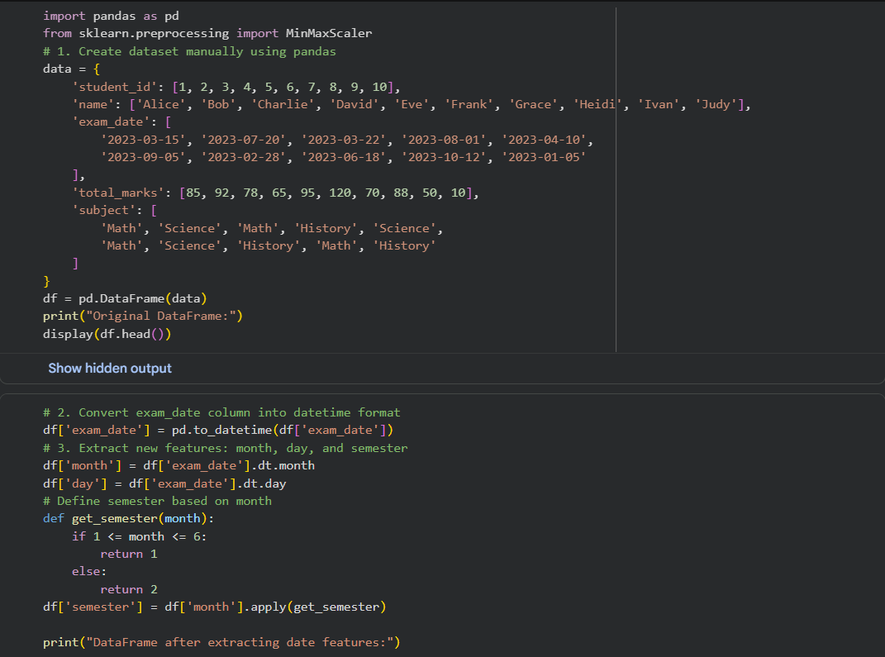
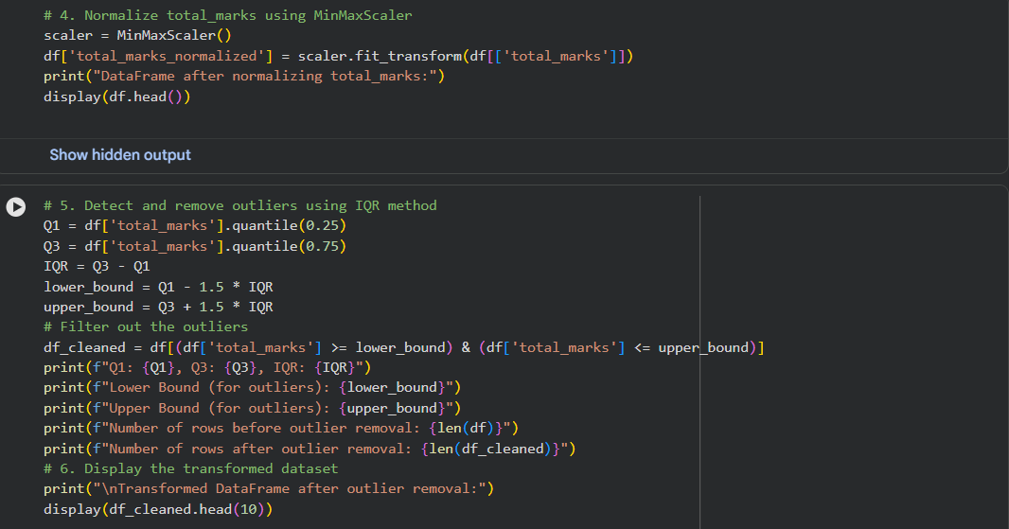
Input:
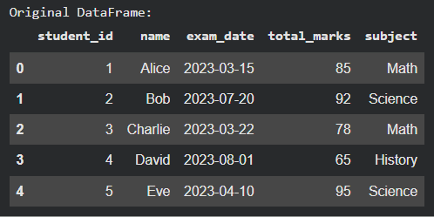
Output:
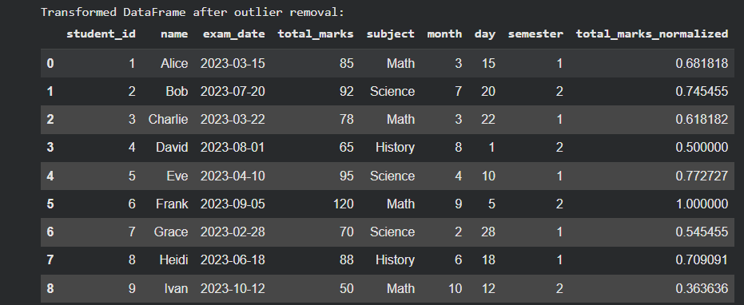
Justification:
In the above task, we performed preprocessing on the student dataset to better understand academic patterns. We converted exam dates to extract useful features such as month and semester. We also normalized the marks to ensure all values are on the same scale, which improves model performance. Additionally, we removed outliers to prevent extreme values from affecting the analysis, resulting in more reliable predictions.

Task 3: Student Health Data Preparation
Prompt used:
Create a Python script for student health dataset preparation. Create dataset manually using pandas.Handle missing values in height, weight, BMI using mean.Encode categorical features (medical_condition, fitness_status) using one-hot encoding.Scale numerical features using StandardScaler.Split dataset into training and testing sets (80:20). Display processed dataset and shapes of train/test sets.
Code:
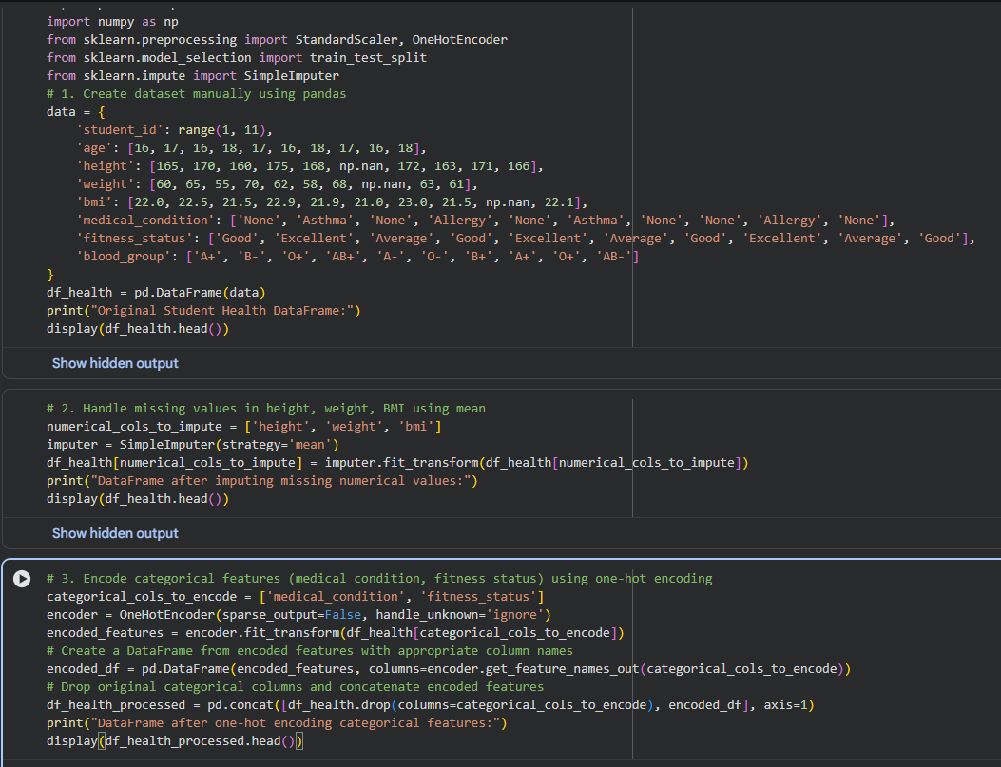
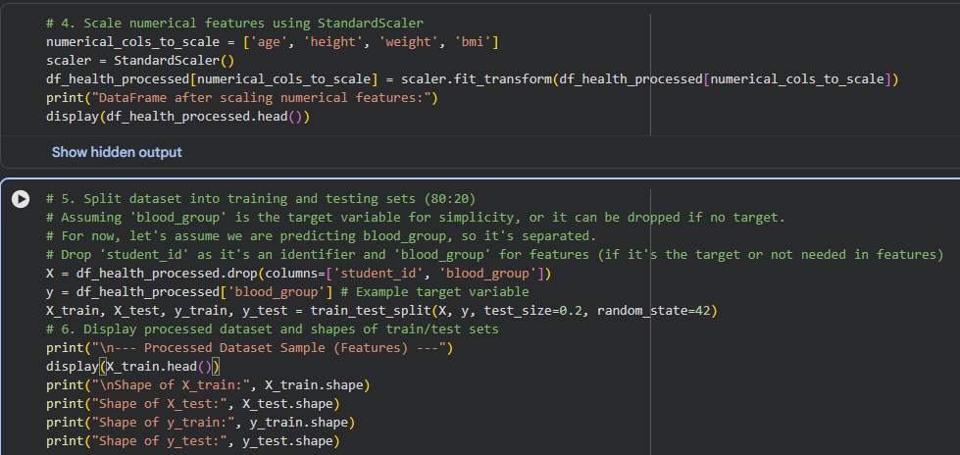
Input:
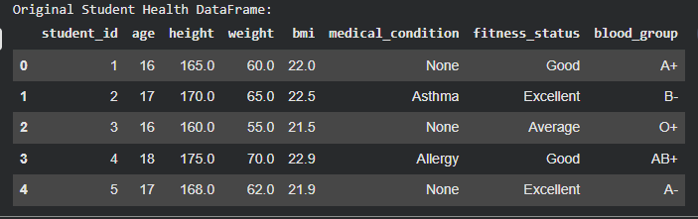
Output:
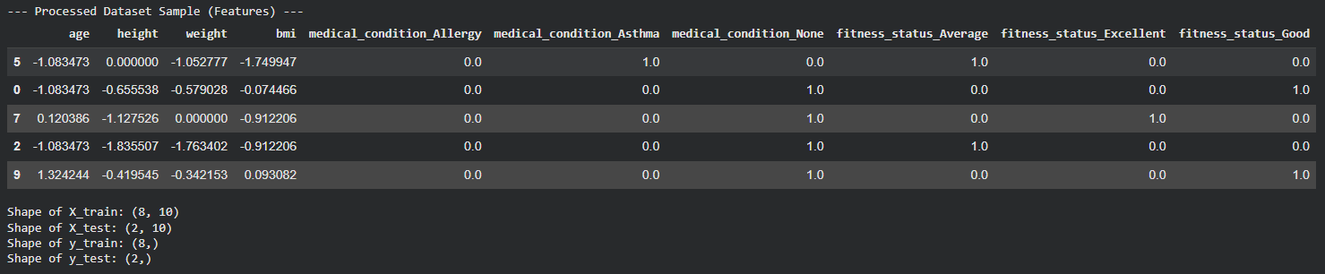
Justification:
In the above task, we prepared the health dataset to build accurate predictive models. We handled missing values in features such as height, weight, and BMI to avoid incomplete records. We also encoded categorical data to make it suitable for machine learning algorithms. Additionally, we applied scaling to ensure all features contribute equally, and split the dataset to effectively evaluate the model’s performance.

Task 4: Real-Time Application: Ride-Sharing Data Cleaning
Prompt used:
Create a Python script in Google Colab to clean ride-sharing data.Create dataset manually using pandas.Standardize pickup and drop locations (lowercase and remove spaces).Fill missing fare values using median.Remove duplicate rows.Normalize driver_rating using MinMaxScaler.Display cleaned dataset.Generate a summary (shape and missing values).
Code:
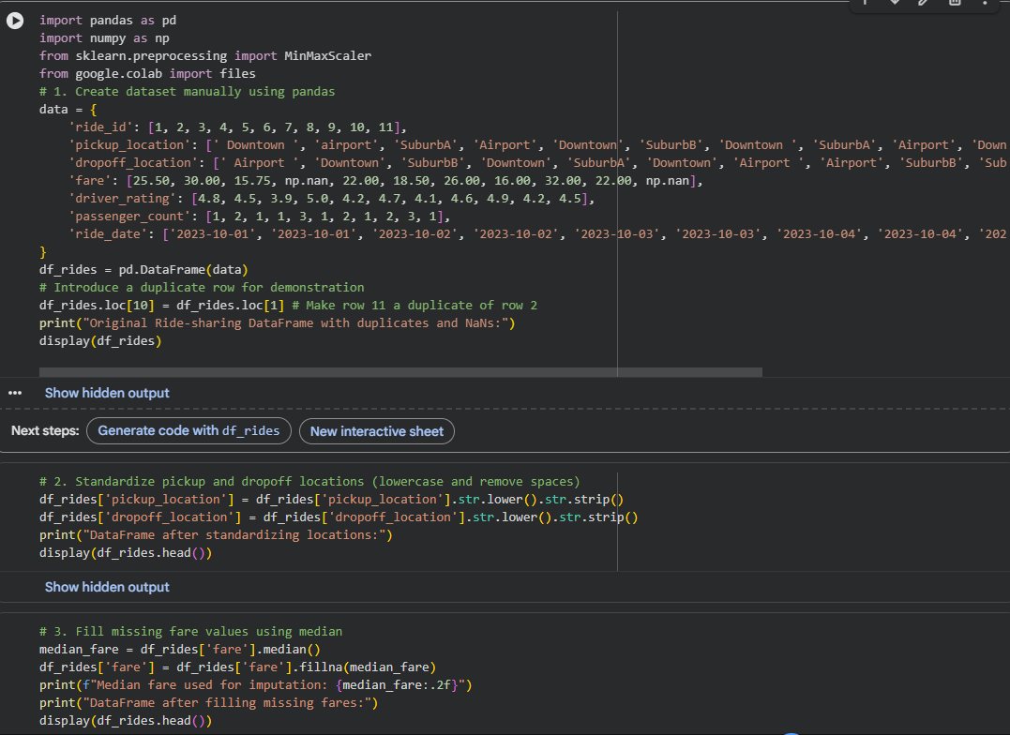
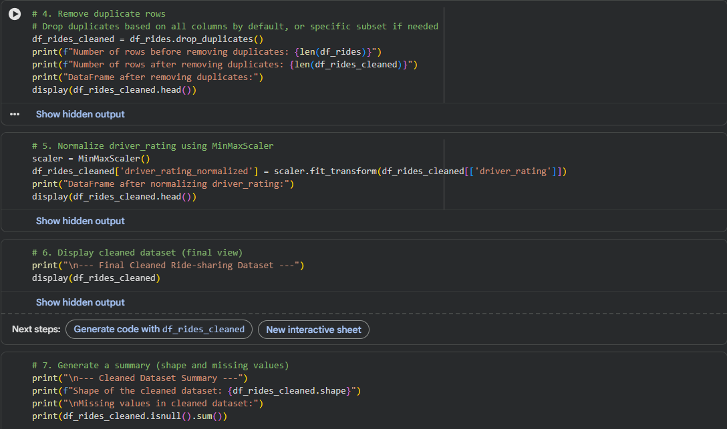

Input:
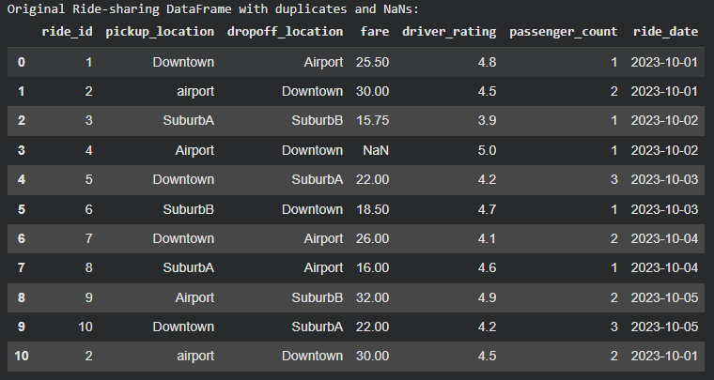
Output:
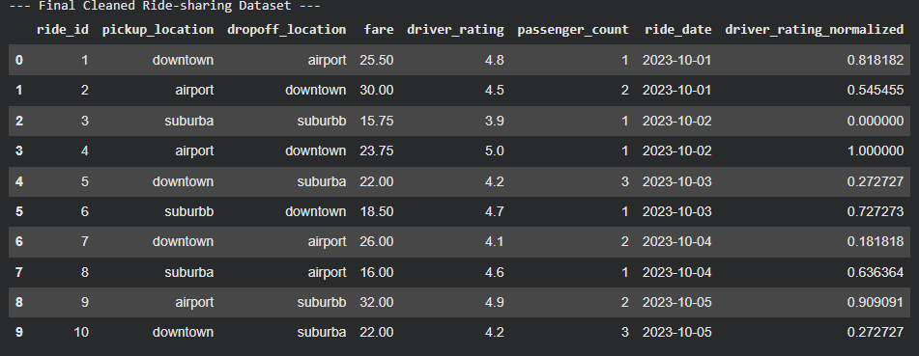
Justification:
In the above task, we cleaned the ride-sharing dataset to improve operational efficiency and support better decision-making. We standardized location names to avoid duplication and confusion. We also filled missing fare values to ensure accurate revenue analysis. Additionally, we removed duplicate entries to prevent incorrect records and normalized ratings for fair comparison. Overall, these steps made the dataset more reliable for business insights and analytics.

